|  |  |  |  |  |  |
| --- | --- | --- | --- | --- | --- |
| Date | 13-Dec-22 | | | Tester Name | Mayuri Patel |
| Environment | Penfax - Test | | | Login used |  |
| Operating System | Select OS | Version: | Update: | | |
| Software Used | Select Software | Version: | Update: | | |
| Select Software | Version: | Update: | | |
| Release version | 22.4.1 | | | | |
| Title |  | | | | |
| Test Type | Regression | | | | |
| Test Scenario | Process PEPP Mailing List | | | | |
|  |  | | | | |
| Expected Results |  | | | | |
| Pass/Fail | Pass | | | JIRA# | N/A |

Describe your steps with screenshots:

Run PEPP Mailing List Batch by adding it to the Batch Process Schedule and Save

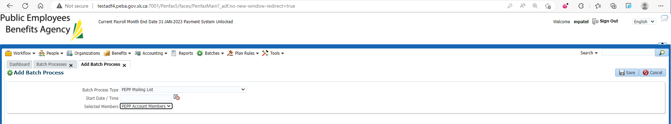

Batch process Running

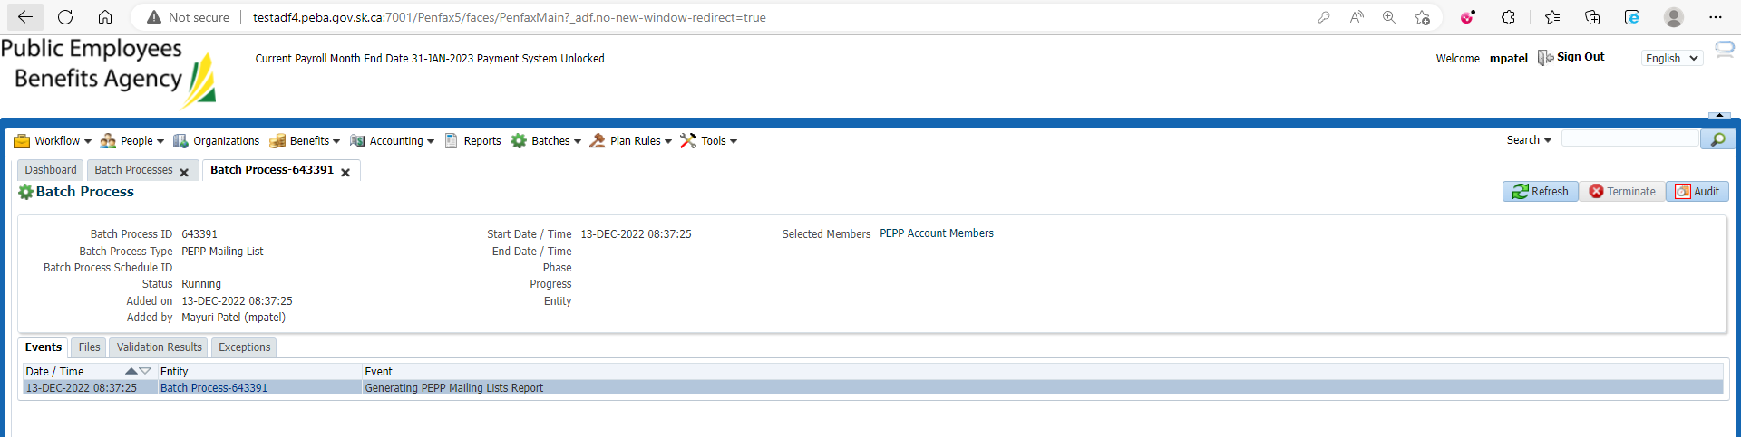

Batch Process Succeeded

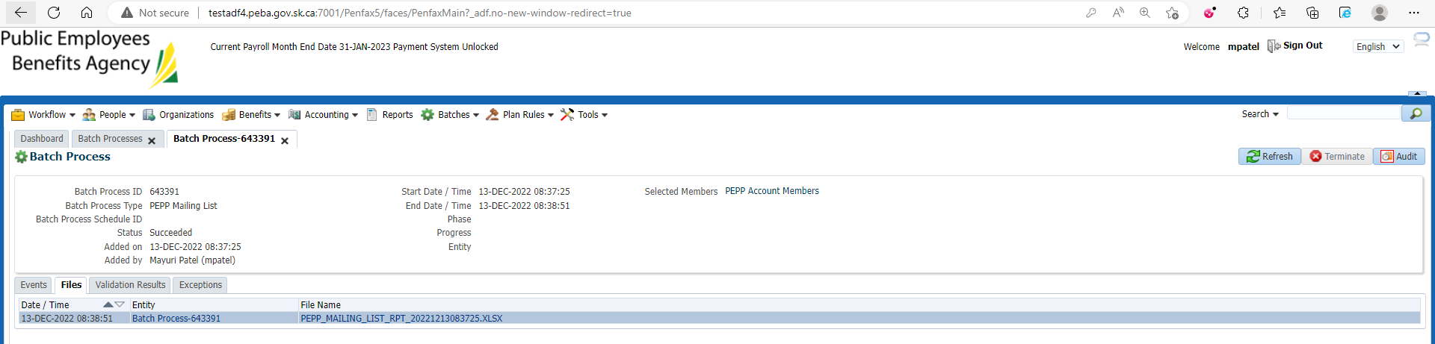

Download and open PEPP Mailing List Report from files tab under Batch process

Select any member from the Report and search for that member in Penfax to verify the Mail Address

­­­­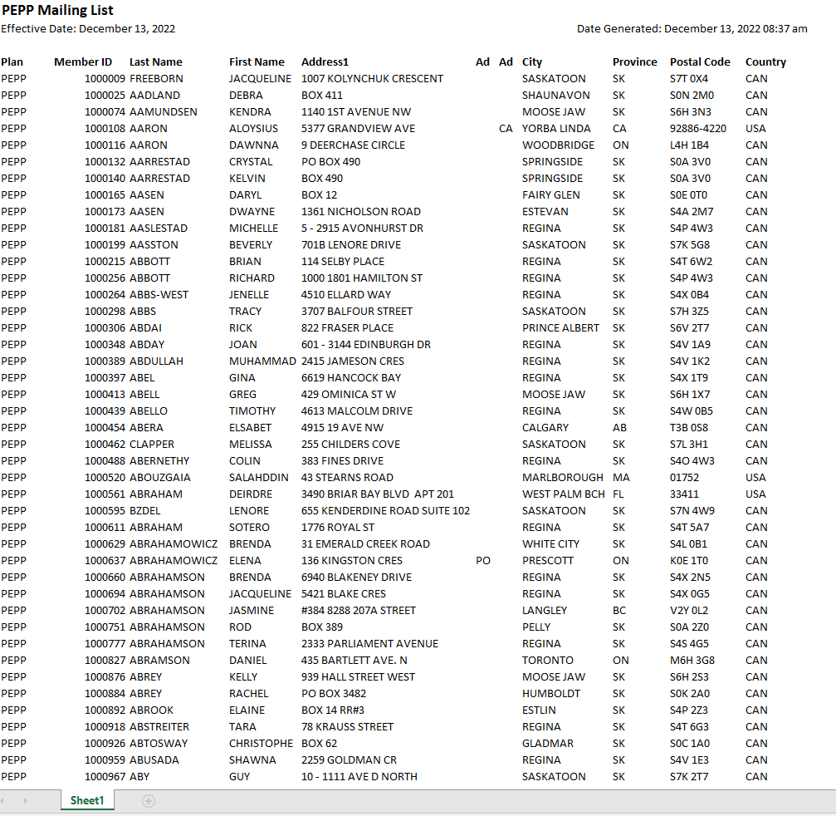

Make sure member address is same on penfax as the report file

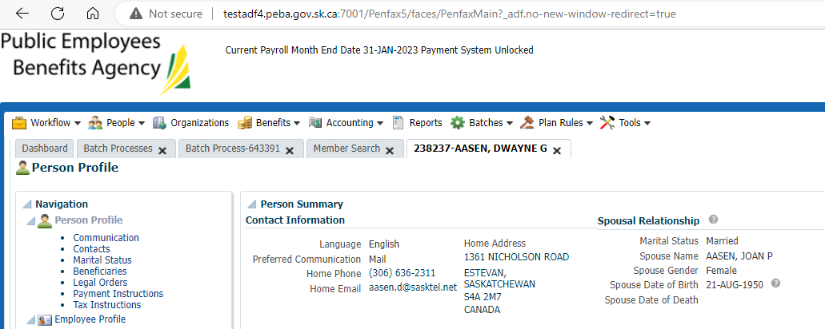

Likewise verify for other members on report file has the same address as on Penfax

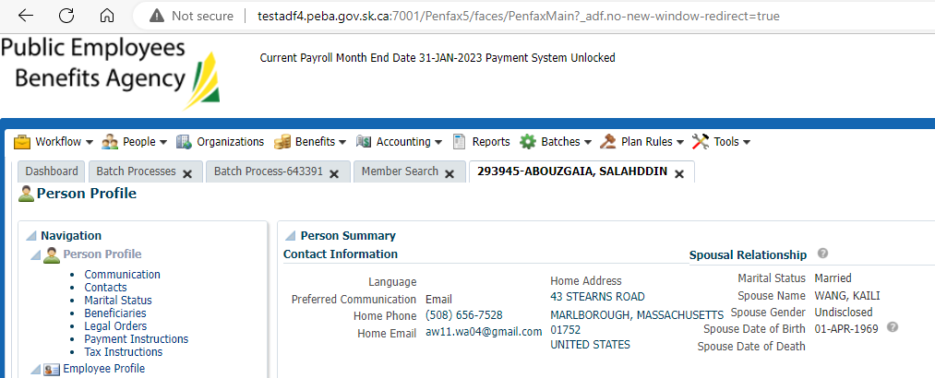

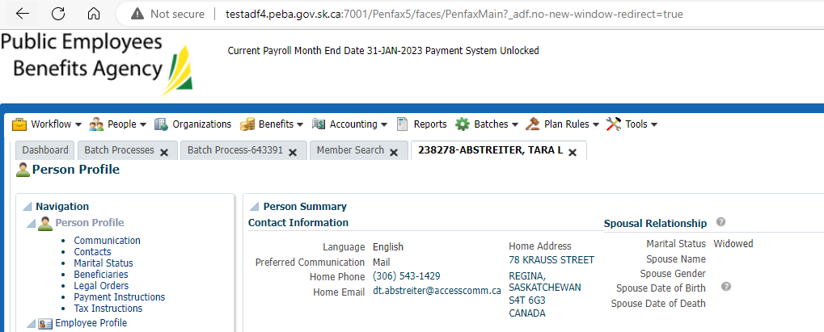

PEPP Mailing List Report is saved at: H:\Quality Assurance\Prod Apps\Testing Management\Regression Testing\Nov 2022 - PENFAX 22.4.1 Release\PEPP\Test Results\E15 Reports